St. Francis Institute of Technology, Mumbai-400 103

**Department of Information Technology**

A.Y. 2024-2025

Class: TE-ITA/B, Semester: VI

Subject: **MAD & PWA LAB**

**Experiment – 1b: Installation and Configuration of Flutter Environment.**

**1. Aim:** To install and configure Flutter Environment.

**2. Objectives:** After study of this experiment, the student will be able to **●** Learn the basics of the Flutter framework.

**●** Install and configure Flutter Environment.

**●** Execute program in flutter environment.

**3. Outcomes:** After study of this experiment, the student will be able to

● Understand cross platform mobile application development using Flutter framework. (L604.1)

**4. Prerequisite:** None.

**5. Requirements:** Personal Computer, 8 GB RAM, Internet Connection, Web browser.

**6. Pre-Experiment Exercise:**

**Brief Theory:**

**Flutter framework**

Flutter is a UI toolkit for building fast, beautiful, natively compiled applications for mobile, web, and desktop with one programming language and single codebase. It is free and open source. Initially, it was developed from Google and now managed by an ECMA standard. Flutter apps use Dart programming language for creating an app.

Flutter is a powerful framework that enables developers to build cross-platform applications with a single codebase, targeting mobile, web, and desktop platforms. It uses a widget-based architecture, where each UI component is a customizable widget, providing flexibility in design.

**7. Laboratory Exercise**

**A. Procedure**

**i. List down the steps to install Flutter framework.**

**ANS**: Here's a breakdown of the steps to install the Flutter framework, covering the most common platforms:

**1. System Requirements:**

Before you begin, ensure your system meets the minimum requirements. Flutter supports Windows, macOS, Linux, and ChromeOS. You'll need sufficient disk space (at least a few gigabytes), and depending on your target platforms, you might need additional software (like Xcode for iOS development or Android Studio for Android development).

**2. Download the Flutter SDK:**

* Go to the official Flutter website:<https://flutter.dev/docs/get-started/install>
* Choose the appropriate operating system (Windows, macOS, or Linux).
* Download the Flutter SDK. It's usually a .zip file.

**3. Extract the SDK:**

* Once downloaded, extract the .zip file to your desired location. It's recommended to avoid directories that require elevated privileges (like C:\Program Files on Windows). A common practice is to create a flutter folder in your home directory or a dedicated development directory. For example: Windows: C:\src\flutter

**4. Update your PATH (Important):**

This step is crucial. You need to add the Flutter tools to your system's PATH environment variable so you can run Flutter commands from your terminal or command prompt. On windows,

* + Search for "environment variables" in the Start Menu.
  + Click on "Edit the system environment variables".
  + Click the "Environment Variables..." button.
  + Under "System variables", find the "Path" variable and select it.
  + Click "Edit...".
  + Click "New" and add the path to your Flutter bin directory. This will be something like: C:\src\flutter\bin (replace with your actual path).
  + Click "OK" on all dialogs to save the changes. You might need to close and reopen your command prompt for the changes to take effect.

**5. Run flutter doctor:**

* Open your terminal or command prompt.
* Type flutter doctor and press Enter.

This command checks your environment for any dependencies that Flutter needs. It will identify any missing SDKs, tools, or configurations. Follow the instructions provided by flutter doctor to address any issues. This might involve installing Android Studio, Xcode, or other dependencies.

**6. (Optional but Recommended) Install Android Studio or IntelliJ IDEA:**

While not strictly required, having a full-fledged IDE like Android Studio or IntelliJ IDEA is highly recommended for Flutter development. These IDEs provide excellent code completion, debugging tools, and integration with the Flutter framework.

* **Android Studio:** Download and install Android Studio from the official website. During the installation, it will guide you through setting up the Android SDK and other necessary components. After installation, you'll need to install the Flutter and Dart plugins in Android Studio.
* **IntelliJ IDEA:** Similar to Android Studio, IntelliJ IDEA is a great IDE for Flutter development. Install the Flutter and Dart plugins to get Flutter support.

**7. Install the Flutter and Dart Plugins (if using an IDE):**

* Open Android Studio or IntelliJ IDEA.
* Go to File > Settings > Plugins (or Preferences > Plugins on macOS).
* Search for "Flutter" and install the Flutter plugin. The Dart plugin will be installed automatically as it's a dependency.
* Restart your IDE after installing the plugins.

**8. Verify Installation:** Create a new Flutter project in your IDE or using the command line (flutter create my_app). Run the default Flutter app (flutter run) on a connected device or emulator to verify that everything is set up correctly.

**B. Result/Observation**

**i.** Installation screenshots.

**ii.** Print out of program code and output.

**8. Post-Experiments Exercise**

**A. Extended Theory:**

1. Describe the Flutter project hierarchy in any IDE (Android Studio or VS Code). **B. Questions:**

1. Execution of ‘Hello world’ program in Flutter.

**C. Conclusion:**

1. Write what was performed in the experiment.

2. Mention a few applications of what was studied.

3. Write the significance of the topic studied in the experiment.

**D. References:**

**1.** https://docs.flutter.dev/get-started/install.

2. <https://www.javatpoint.com/flutter>

**Flutter Installation on Windows:**

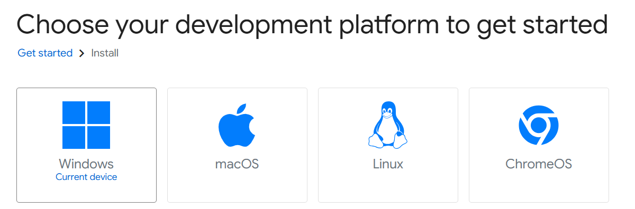

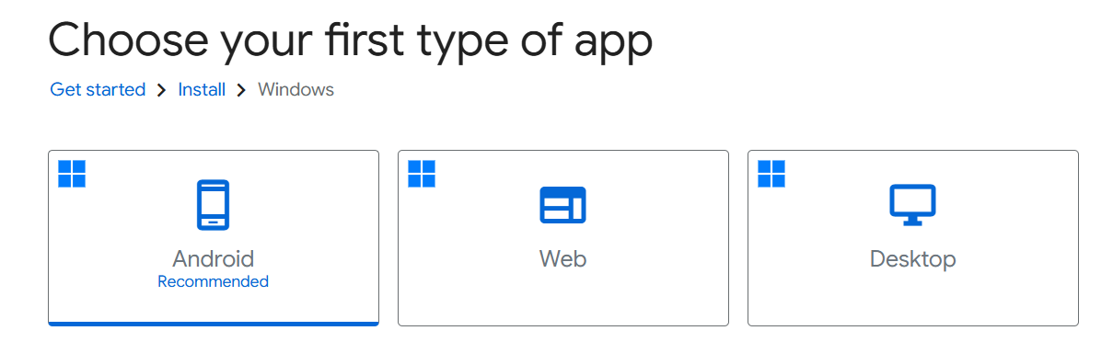

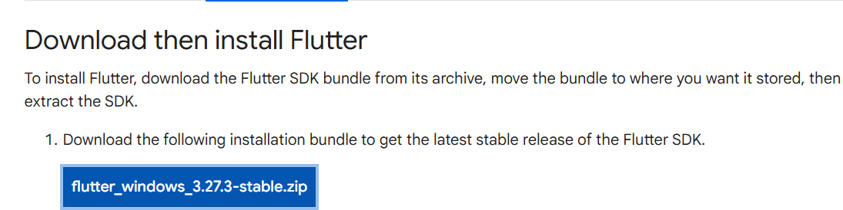

|  |  |
| --- | --- |

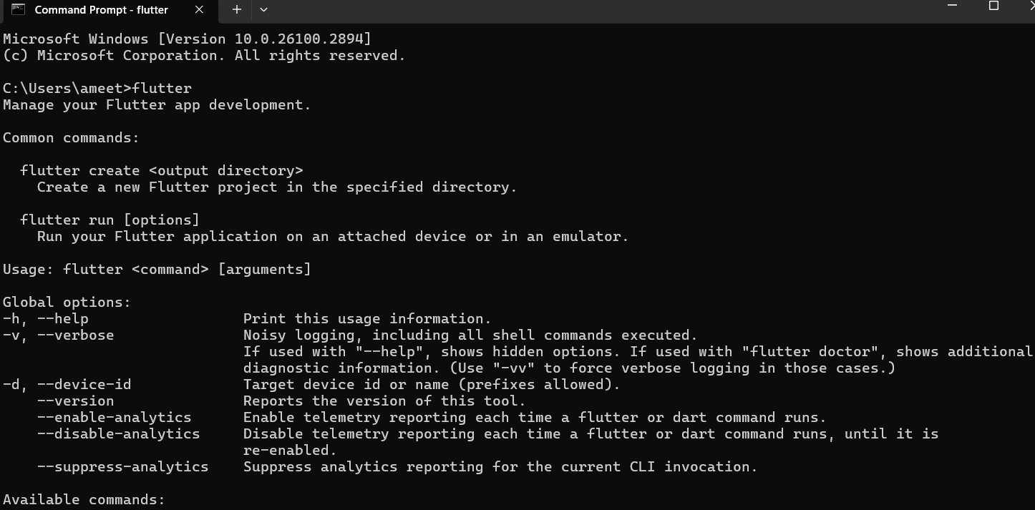

**Installation of Android Studio :**

|  |  |
| --- | --- |
|  |  |

|  |  |
| --- | --- |
|  |  |

|  |  |
| --- | --- |
|  |  |

**Configuring Flutter in Visual Studio Code :**

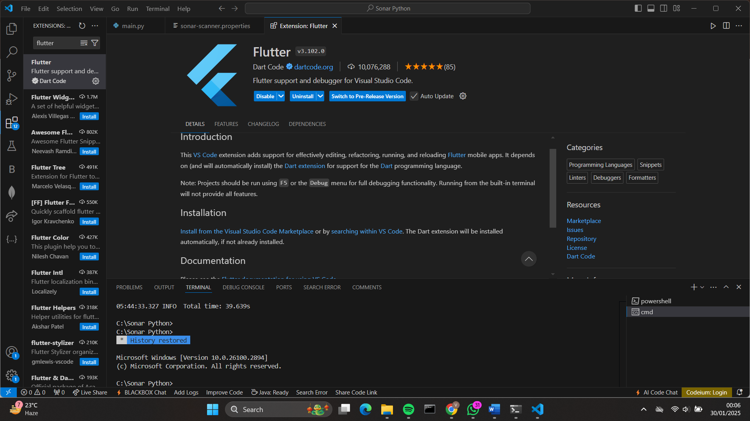

**8. Post Experiment Exercise:**

**B. Questions:**

**1. Execution of ‘Hello world’ program in Flutter.**



